**Best dating spot in Pokhara**

Pokhara is one of the most beautiful city in Nepal, talking on six best dating spot in Pokhara for young people, young guy are found searching on google for best place so we have written this article.

Let us list top best six places for dating in Pokhara.

**Best dating spot in Pokhara**

1. Lakeside

[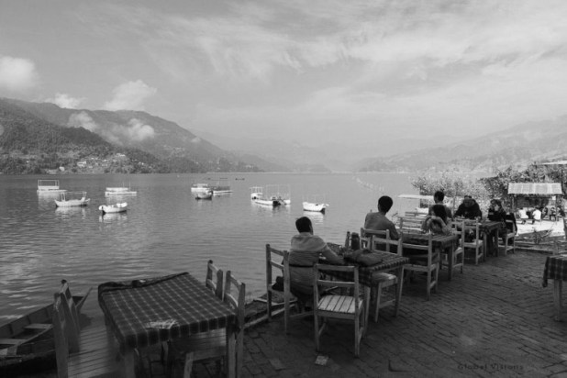](http://i0.wp.com/www.mazza6.com/wp-content/uploads/2015/08/best-dating-spot-in-pokhara-2.jpg)

**Best dating spot in Pokhara**

Lakeside is the main attraction of Pokhara, Pokhara this name is interattached with Lakeside mean that without lakeside Pokhara is Incomplete. Most of young guy and lots of tourist who come to Nepal once visit Pokhara, Lakeside.

Around lakeside we can found many places suitable for dating. Temple in Lake is best place to hang out and many religious tourists also come in Temple. There are many hotels and resturant to hang out. So during the time of new year and different festival lakesides seems to have lots of international and national Tourist.

**Best dating spot in Pokhara**

1. Majhikuna[( Begnas Lake)](http://www.begnas.com/" \t "_blank)

[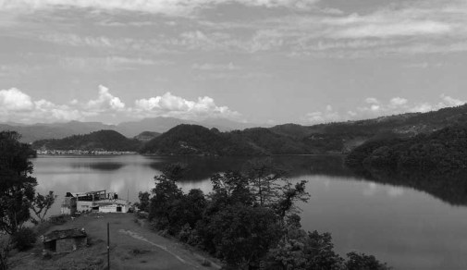](http://i0.wp.com/www.mazza6.com/wp-content/uploads/2015/08/best-dating-spot-in-pokhara-4.jpg)

**Best dating spot in Pokhara**

Majhikuna is one of the best place for tourist to hang out, naturally it is majhikuna have glommy environment, Begnas Lake infront of majikuna seems to be second largest lake From Pokhara and first largest of Lekhnath Municipality.

1. Sarangkot & Lama Gau

Sarangkot is Famous place for Paragalding in Pokhara, 1000 of tourist come yearly For Paragalding, not only international tourist national tourist also comes for paragaliding. Sarankot is also best place for young especially for dating spot; you can see Machapuchree and different Mountain Clearly from Sarangkot.

[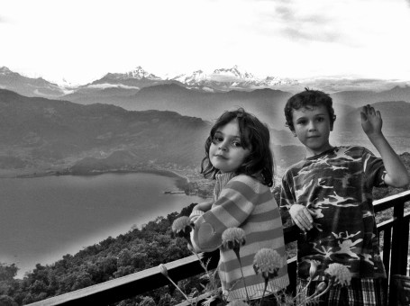](http://i2.wp.com/www.mazza6.com/wp-content/uploads/2015/08/best-dating-spot-in-pokhara-3.jpg)

**Best dating spot in Pokhara**

1. Shanti Stupa

Shanti Stupa stuited at the top most Hill part of Fewa lake, at the top most andanda hill the stupa is situated there are many dating spots around this hill soo many couples come for date over here.

[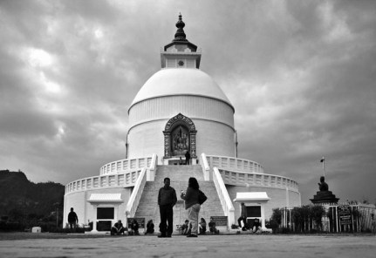](http://i1.wp.com/www.mazza6.com/wp-content/uploads/2015/08/best-dating-spot-in-pokhara-5.jpg)

**Best dating spot in Pokhara**

1. Baundahara Park & Komagane park

These 2 are more famous parks here in Pokhara, basundhara and komagane are parks on the way to lakeside, many events and festival are hosted at this park too. Nearby lake phewa lake this peripherial is more famous for dating especially more couples are seen at basundhara park in compare to komgane park.

[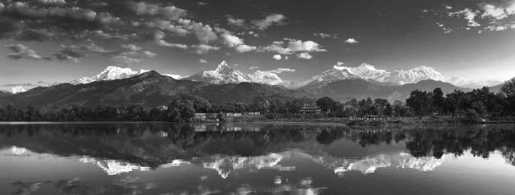](http://i2.wp.com/www.mazza6.com/wp-content/uploads/2015/08/best-dating-spot-in-pokhara-6.jpg)

**Best dating spot in Pokhara**

1. Lovely Hill

This hill is named after when many couples found but these days people enjoy morning walk and evening walk and less couples are found date here soo last bt not the list at the top 6 lovely hill is listed as one of the best dating place in Pokhara.

There are many other best dating spot in Pokhara, many other are missing because Pokhara is naturally reach and among them we have listed above six if you also know other destination please comment

[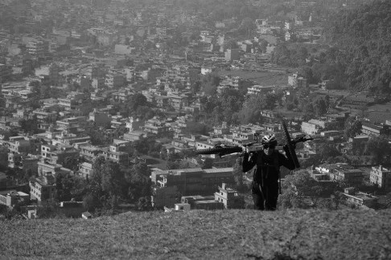](http://i0.wp.com/www.mazza6.com/wp-content/uploads/2015/08/best-dating-spot-in-pokhara-1.jpg)

**Best dating spot in Pokhara**